Assignment 1: Simple SQL Query with a single table with where clause

Database Name: Northwind database

Query: Create Database Northwind
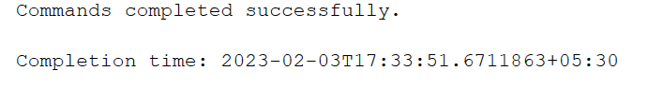
Table Name :
Products:
- ProductID
- ProductName
- SupplierID
- CategoryID
- QuantityPerUnit
- UnitPrice
- UnitsInStock
- UnitsOnOrder
- ReorderLevel
- Discontinued

Query:
CREATE TABLE Products (
ProductID int NOT NULL PRIMARY KEY,
ProductName varchar(40) NOT NULL,
SupplierID int,
CategoryID int,
QuantityPerUnit varchar(20),
UnitPrice real,
UnitsInStock int,
UnitsOnOrder int,
ReorderLevel int,
Discontinued bit NOT NULL,
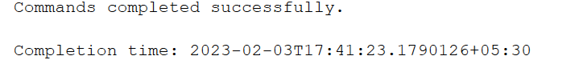
);

1. Write a query to get a Product list (id, name, unit price) where current products cost
less than $20.
Ans

Query:

select Productid,productname,unitprice from products where unitprice<20;

Output:
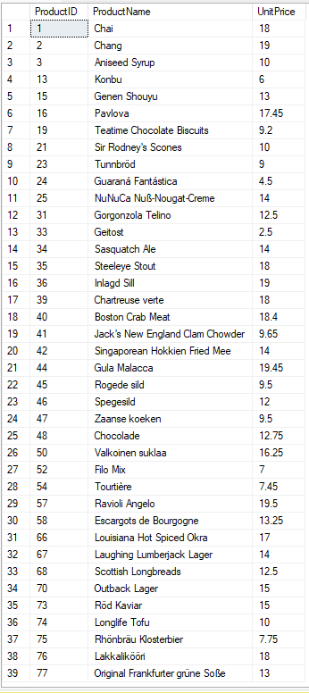

2. Write a query to get Product list (id, name, unit price) where products cost between
$15 and $25
Ans:

Query:

select ProductID,ProductName,UnitPrice from products where unitprice>15 and unitPrice<25;

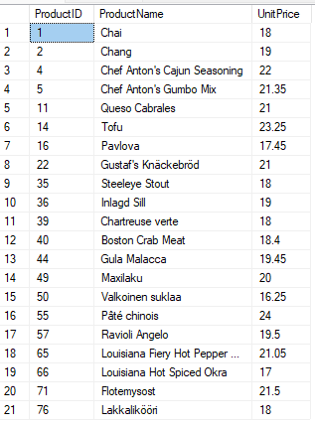
Output

3. Write a query to get Product list (name, unit price) of above average price.
Ans:
Query:

select ProductName,UnitPrice from products where unitprice>( select AVG(unitprice) from products)

Output:
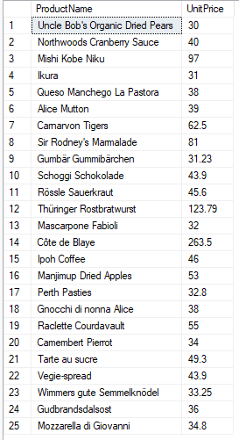

4. Write a query to get Product list (name, unit price) of ten most expensive products
Ans:

Query:

Select top 10 ProductName,UnitPrice from products order by unitprice desc

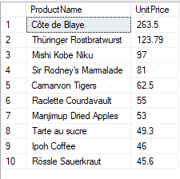
Output:

5. Write a query to count current and discontinued products
Ans:

Query:

SELECT Discontinued,Count(*) as Product_Count
FROM Products
GROUP BY Discontinued;

Output:

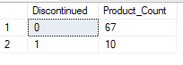

6. Write a query to get Product list (name, units on order ,units in stock) of stock is less than the quantity on order
Ans:

Query:

Select ProductName,UnitsOnOrder,UnitsInStock
from products where UnitsInStock<UnitsOnOrder

Output:
